**WORK INSTRUCTIONS FOR** **SLAG DRIER OPERATION**

**Criteria:** Safe Firing of Gas, Quality & Prevention of Pollution.

**OVERALL RESPOSNSIBILITY:** SLAG DRIER INCHARGE/SLAG DRIER OPERATING WORKMAN

**Identified Hazards:**

1. Mech Falling /impact

2. Fire & explosion

3. BF Gas poisoning

4. Contact with dust

1. Electric shock
2. Human Behavior -Non use of PPE
3. Human Behavior-Improper house keeping
4. Inadequate local lighting
5. Human error, Human behavior
6. inhalation of dust
7. Injury while operating equipment (Valves)
8. Impact of magnet to the person
9. Diesel spillage from tank

**Significant Aspect:**

Emission of dust

Emission of flue gases

Vehicle emission

Generation of dust

Use of electrical energy

Usage of water

Spillage of Diesel

1. Unauthorised operation/repair of any equipment is a punishable offence
2. All persons working at the slag drier should wear dust mask, safety goggles, helmet, safety shoes and hand gloves.
3. No person wearing loose clothes should be allowed to enter in the slag drier plant premises.
4. Tool box talks should be given to all workman at the start of the shift
5. Guards of moving equipment’s, conveyer guards and kiln area barricade should be checked once in the shift.
6. Healthiness of pull chords should be checked once in the shift.
7. No gas cutting and welding should be allowed on the diesel tank and its platform.
8. Spare LPG cylinder should be always locked.

**SHUTDOWN OF SLAG DRYER PLANT**

1. Stop the feed
2. Ensure that there is no material on the feed belt.
3. Trip the BF gas & close the BFG manual valve.
4. Stop the Kiln.
5. Stop the dilution fan.
6. Water seal the gas line water seal provided near the control panel. (Do not forget to open & close the gas relief valve).
7. Stop the ID fan. (Run for 05 minutes after water sealing)
8. Stop the booster pump.
9. After the shut down procedure is completed, close all the manual air line valves.

**STARTING OF SLAG DRYER PLANT**

1. Ensure that all the work permits have been cleared before starting the dryer
2. Start the siren
3. Start the booster pump of the settling tank which is in line. There is an interlock between pump and ID fan starting. If the settling pond pump stops,   kiln ID fan stops  resulting in the kiln, feed belt stopping and BFG burner valve closing.
4. Close the ID fan damper and start the fan, when the ID fan falls in delta gradually open the damper, till draft is -25 mmwc.please ensure that the ID Fan Damper handle is in contact with the limit switch before starting as this an interlock given for Fan starting. ID Fan Damper handle can be locked to desirable draft.
5. Break the water seal near the burner control panel.
6. Start the dilution fan, with damper in closed position. Adjust draft to - 10 mm wc.
7. Start the Electro magnet.
8. Start conveyor belt no 2.
9. Open all the manual air & diesel line valves (manual).
10. Open manual BFG shutoff valve
11. Start the diesel pump
12. Start the kiln.
13. Start the FD fan with damper in closed position, open 15 % of the damper, open the LPG regulator and adjust the pressure of LPG to 4 kg.
14. When all the above is done, on the control panel limits OK will appear.
15. Now press the purge start button. And the burner will fire automatically.
16. When the temperature goes to 450 OC, open the BFG pneumatic valve.
17. Then gradually open the BFG regulating valve by giving desired set point so as to adjust gas flow to achieve the desired temperature.(As per the written instruction).
18. Stop the diesel pump. And close the diesel valve (Ball valve).
19. Stop LPG and close the LPG regulator.
20. Start the screen first then conveyor belt no 1 followed by vibro feeder
21. Kiln draft to be always maintained at - 6 mmwc.at the burner end.
22. .Maintain the burner temperature below 820 0C and draft temperature 700C.
23. Points to note for controlling dried slag moisture %.
24. When the output temperature starts increasing (temp should not increase more than 110 OC). Start the feed, as soon as the output temperature starts decreasing the feed is to be stopped.
25. Ensure that the moisture content is below 2.0%.
26. Send one input sample and one output sample to lab every shift. **Output sample**: One sample is taken every hour and a composite sample at the end of the 8 hour shift is sent to the lab for moisture content analysis. .
    1. Input slag moisture sample should be taken from the heap of slag being charged.
    2. Output sample should be taken from the inspection chamber in the output chute of belt number 2.
    3. Under no circumstances sample should be drawn from the running conveyer belt.

Magnetic separation.

Magnetic chips are compulsorily to be removed, after every 05 minutes of running of the belt, with the help of the sliding mechanism provided below the electromagnet and from the chute at the magnetic drum at the discharge end of the belt-2.

Magnet operation has been automated wherein the Electro magnet to and fro operations happens within the time set in the PLC for magnetizing /De-magnetizing . The Time can be set based on the regular physical verification of the quantity of chips that is being captured by the Electro magnet when the plant is in operation.

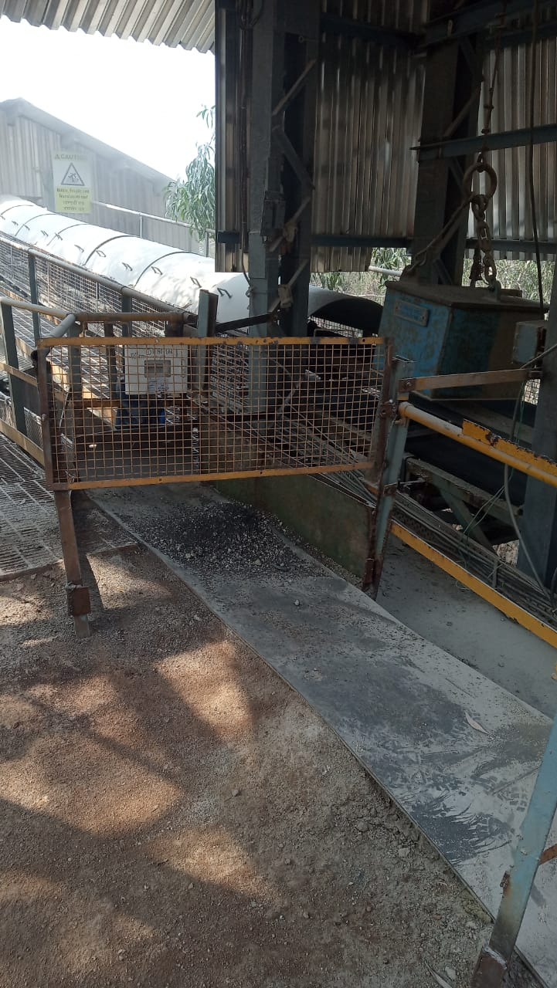 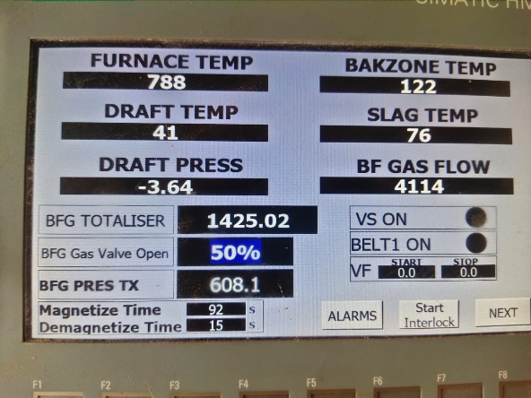

**Guidelines for the personnel working in the slag dryer plant**

1. No person should attempt to clean below any conveyor belt or other rotating or moving equipment
2. During major shutdown of the dryer & while cleaning inside the kiln, the gas line has to purged with steam and blanked.
3. When the plant is under shutdown the main power supply has to be kept off and' Men at Work ' board should be displayed Safety belt should be used while cleaning in the draft duct.
4. Following procedure should be followed for cleaning grizzlies of the feeding bunker
   1. Cleaning of grizzly at the receiving hopper should be done by emptying the hopper, stopping the feeder, and putting the link chain across the hopper.
   2. Excess slag if any should be removed using wheel loader to the maximum possible extent.
   3. Lightweight aluminium gratings should be used for moving across on the bunker grizlly.
5. While cleaning inside the ID and below belt-2, ensure that electrical shutdown/ LOTO lock is applied to the equipment.
6. The cleaning of water sprays should be carried out during shutdown only.
7. Changing of the settling ponds is to be carried out only during shutdown.
8. Magnetic material cleaning has to be carried out by taking out the magnet from the belt.
9. While filling the hopper the labourers have to stand at a safe distance.
10. Cleaning at the I.D. fan has to be carried out only during shutdown.
11. Cadmium compound to be applied to the guide rollers only through the opening provided.
12. The burner should not be fired in manual mode
13. The diesel tank has to be checked before start-up and also ensure that diesel filling valve should be in the closed position.
14. Processed slag output temperature should be maintained between 100 0C and 110 OC
15. Before starting the plant all the workers in the plant have to come to the control room. & they have to be given safety instructions
16. While filling the hopper. the wheel loader should not cross the barricade provided at the receiving hopper.
17. Clearance to dispatch dept., for loading processed slag from the shed, should be given by 08.30 hrs.
18. In case any abnormalities are noticed in the processed slag , the loading has to be discontinued
19. The wheel loader has to be readily available all the time.
20. The input and output chutes have to be checked daily in the day time for jamming, if any. They have to be cleaned, if found jammed
21. The gas relief valve should be kept closed after water sealing / steam purging the gas line.
22. The W/L operator should wear full sleeved cotton clothes & should be alert while operating the machine in the concerned area He should ensure a clear 5.0 meter distance to be maintained between the edge of the road and the slag heap.
23. Clean the cyclone regularly so that excess slag dust should not go to the atmosphere through the stack.
24. Care should be taken while cleaning the cyclone (by regulating the butterfly valve) so that there should not be excess generation of slag dust
25. Ensure that the saturator water sprays are cleaned during every shutdown.
26. The SPM level in the stack and the ambient air quality around the area should be measured as and when required.
27. Ensure proper functioning of the saturator water sprays.
28. Saturator sprays, cone, settling tank & ID fan are to be cleaned every day during day time.
29. Spilled dry processed slag collected from the area below belt number 2 can be put on the belt number 2 as per following procedure
    1. Slag should be completely dry
    2. Slag below belt should be removed out before starting the belt.
    3. Ensure that all guards of the belt are in place and no rotating part can come in contact of the person working.
    4. Ensure that no person is working on or below belt number 2
    5. Activate siren
    6. Start belt number 2 from the local push button.
    7. Put the slag collected on belt number 2 from the chute provided for putting cyclone slag.

**Cleaning of settling tank;**

1. Periodical check is to be done and the tank is to be assessed for quantum of sludge settled.
2. Tank is drained by opening drain flange and stopping the booster pump by Push button.
3. After water is totally drained washing of fine sludge is done keeping the drain flange open.
4. Pickaxe,pawda is used for cleaning ,Tank is also Checked for cracks at suction pipe side.
5. Person will enter inside after tank is fully drained with Gum boots,, goggles, hand gloves.
6. Flange is fitted on the recirculation water pipeline outlet for restricting water from falling into the tank which is being cleaned.
7. If there is no further cleaning required then water is filled in the tank and kept ready for taking it in line.

**Cleaning of burners**

1. Before taking up this activity BFG is withdrawn, shutoff valve is closed and the kiln is run keeping the ID fan running for about 10 minutes.
2. Water sealing of the BFG line is done
3. After water sealing clearance is given to Mechanical to open the burner cashew nut flanges for cleaning the burner.
4. Burner cleaning involves cleaning of the deposited dust in the concentric pipe through which BFG flows before burning. Cleaning is done with lancing pipe edge which is either sharpened or bent to facilitate cleaning inside the concentric pipe.
5. On completion of cleaning all dust is pulled out using the bent lancing pipe hook and clearance is given to mechanical to close and seal all flanges with sealing compound to prevent any BFG leakages.

|  |  |  |
| --- | --- | --- |
| **Prepared By:**  Head – Production PID I | **Reviewed & Issued By:**  Management Representative | **Approved By:**  Head – PID |
| **Signature:** | **Signature:** | **Signature:** |
| **Date: 10.07.2023** | **Date: 10.07.2023** | **Date: 10.07.2023** |

|  |  |  |  |
| --- | --- | --- | --- |
| **Amendment Record** | | | |
| **Revision date** | **Manual Section ref. and para** | **Brief details of revision** | **New Revision No.** |
| 07.12.2020 | Starting of Slag dryer plant | Magnetic separation | 07 |
| **12.07.2021** | **Slag dryer operation** | **Settling tank cleaning** | **08** |
| **15.07.2022** | **Starting of slag drier plant**  **Cleaning of Burners** | **Change in format**  **Point 3**  **Guidelines for cleaning of burners** | **09** |